Name**:** YashBhavsar

Enrolmentnumber:2302030430006

Branch: C.E-3(D2D)

**Task-2**

**HOME PAGE**



**ABOUT**





**SERVICES**



**PORTFOLIO**



**CONTACT US**

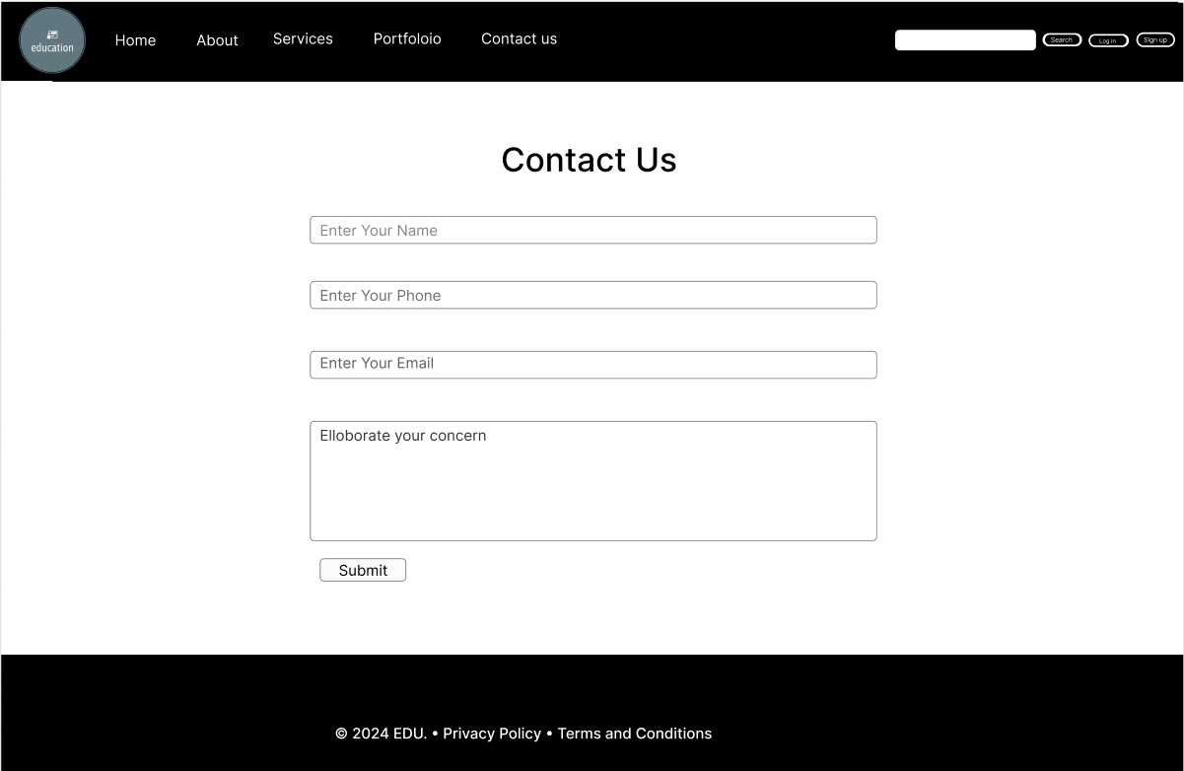

**LOG-IN PAGE**

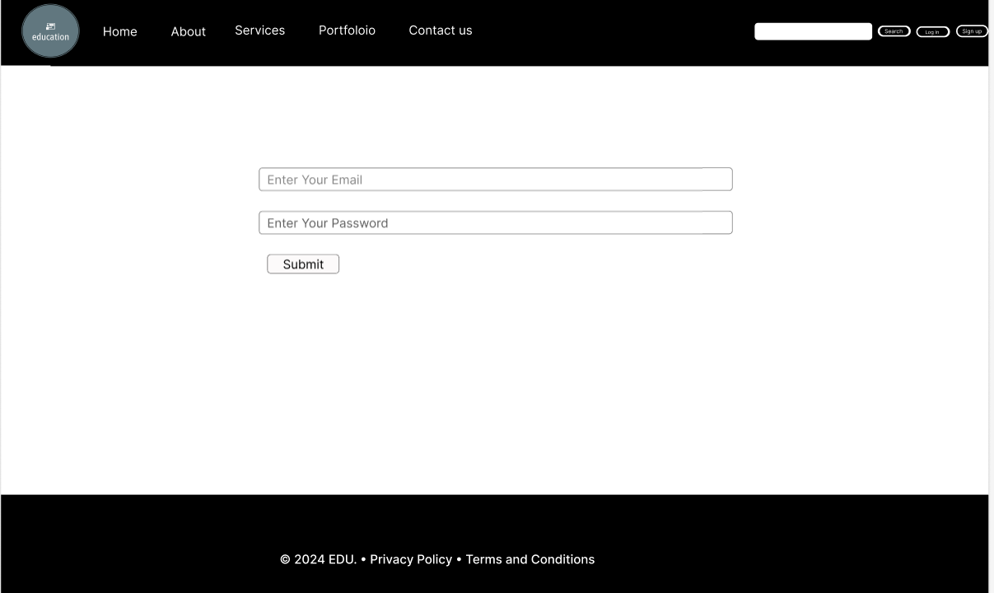

**SIGN UP PAGE**

